Help to register entries for several children
- After you have registered one child on the BMWCCV Events portal, you will see a message ‘Already registered’
- Simply use the ‘Register’ button again to register a second child.
Repeat the ‘Register’ process for more children if needed.
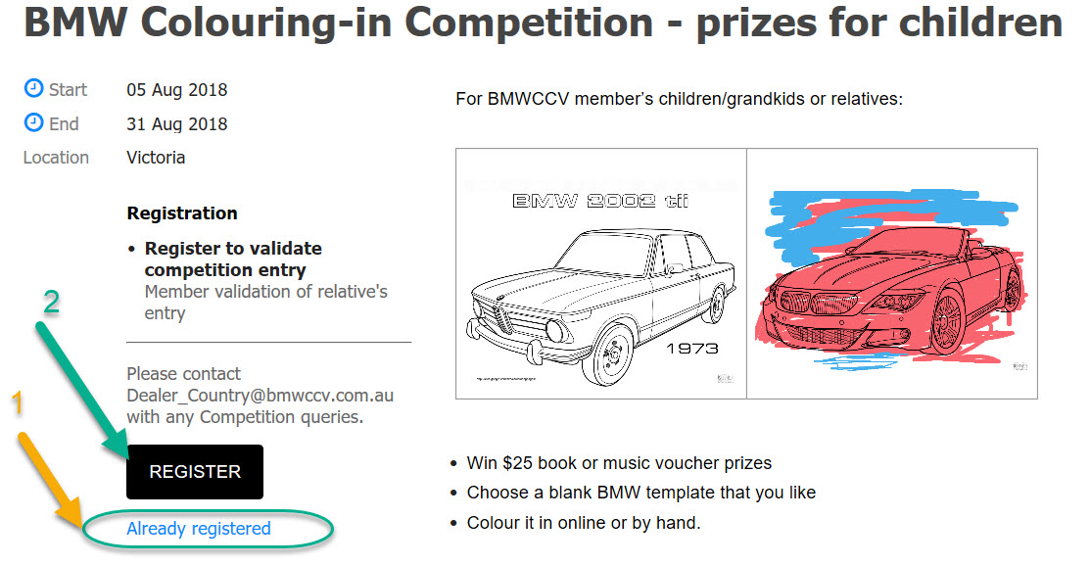

If you want to see your registration details or a list of all the children that you have validated for competition entry, click the ‘Already registered’ link

